Maddison Marshment, EM and Luke Ponsford-Spencer

Is there a bunker beneath the grounds?

Pressing questions

Rumours have been circling the grounds of the school, of a concealed bunker and a dark history. People participating in the conjecture claim that the long-forgotten shelter resides under the grass verge by the pupil entrance.

The Pressing Questions teams online research indicated that Longdon Park School has previously been a medical facility in the war, offices, training and agricultural centre and used as a bomb planning facility. It was also previously called Park Hill and was owned by a man called Mike, who our sources described as eccentric.

We interviewed Ali Worth, deputy head. This is how our conversation went: Ali mentioned that his source of information was Paul Platts. Paul Platts said that on the original plans for the building, there is no bunker. But on older plans there does appear to be. If you go into the cellar there is a room with big heavy bars on it. The cellar also has archways that head in the direction that the bunker might be. There is very neat brickwork and it is clear that someone bricked it over. The question is, what is concealed behind the wall and why would someone decide to hide whatever is behind from the world?

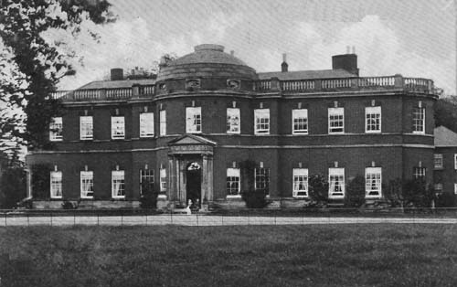

We contacted Paul Platts, who gave us some information and the plans for the building. One set of plans show a corridor leading to something. He suggested that Mike, the eccentric previous owner could have dropped in a bunker behind the corridor shown on the plans. Paul said that Mike might not have put the bunker on the plans because of ‘nosey neighbours’ and not wanting to apply for planning permission.

However, there are theories that below the dirt of brick of our schools grounds there lies a sinister secret concealed from our eyes. Sources informed us that when they have been in the building after hour they have experience flickering lights and thudding from the direction of where the bunker is suspected to be. The question is, what is this hidden for malevolent or benevolent reasons?